

**GLOBAL POWER PLANT DATABASE PROJECT**

**In This dataset we will make two predictions .**

**1. Primary** **Fuel**

**2**.**capacity_mw**

In this blog , I will go through the whole process of creating machine learning models on the famous GLOBAL POWER PLANT dataset .

The Global Power Plant Database is a comprehensive, open source database of power plants around the world. It centralizes power plant data to make it easier to navigate, compare and draw insights for one’s own analysis. The database covers approximately 35,000 power plants from 167 countries and includes thermal plants (e.g. coal, gas, oil, nuclear, biomass, waste, geothermal) and renewables (e.g. hydro, wind, solar). Each power plant is geolocated and entries contain information on plant capacity, generation, ownership, and fuel type.

Importing the Libraries

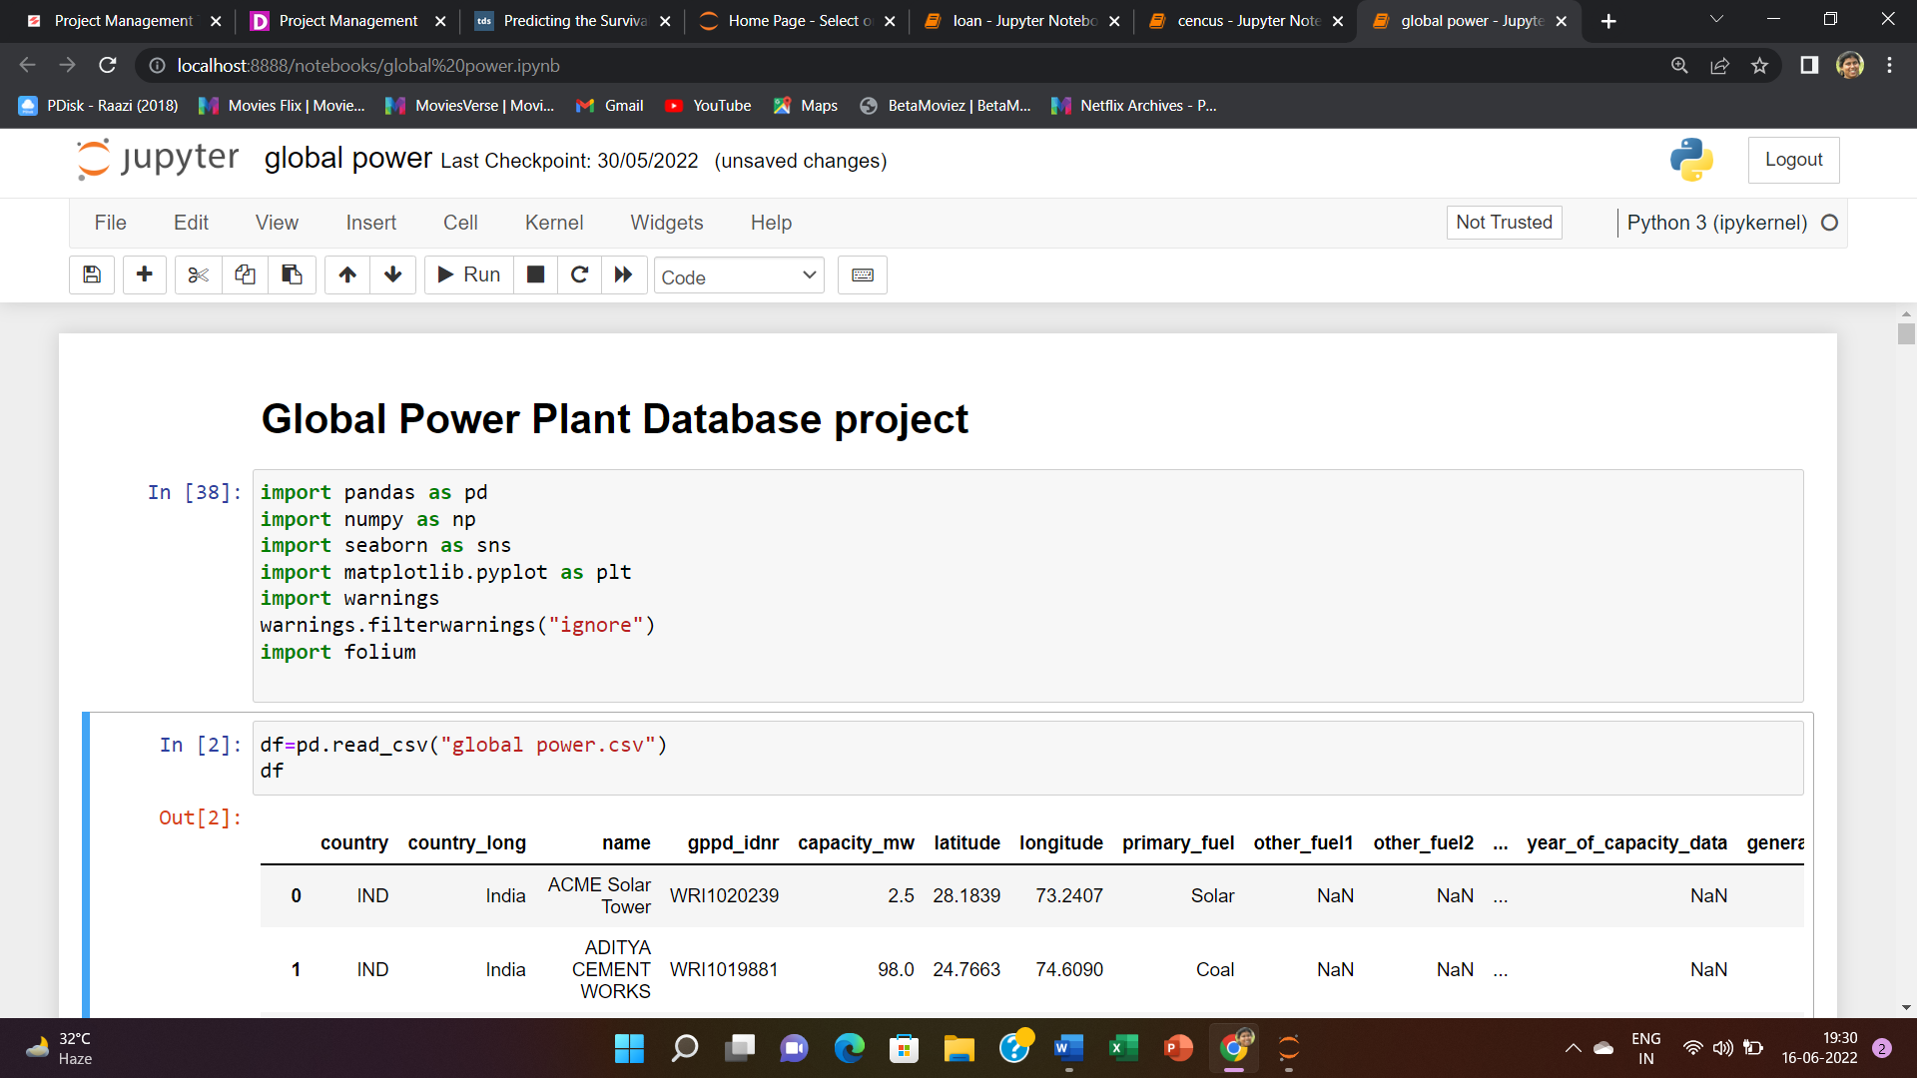

Uploading the csv file of the dataset

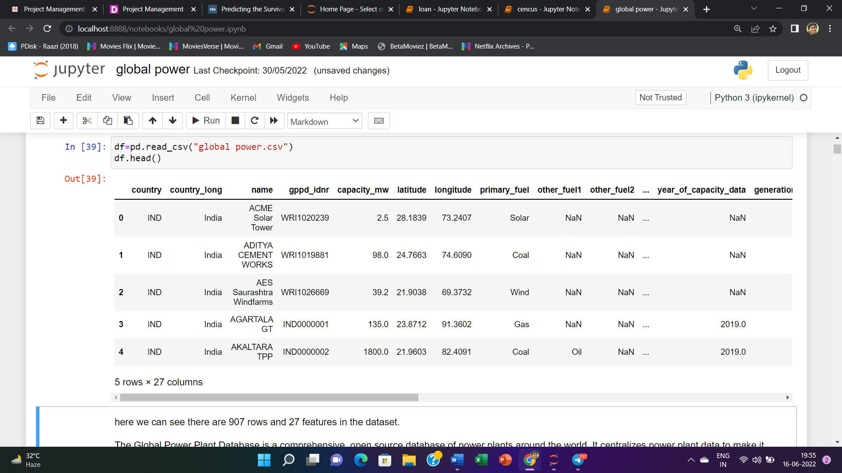

here we can see there are 907 rows and 27 features in the dataset .

Key attributes of the database :

country (text): 3 character country code corresponding to the ISO 3166-1 alpha-3 specification

country_long (text): longer form of the country designation

name (text): name or title of the power plant, generally in Romanized form

gppd_idnr (text): 10 or 12 character identifier for the power plant

capacity_mw (number): electrical generating capacity in megawatts

latitude (number): geolocation in decimal degrees; WGS84 (EPSG:4326)

longitude (number): geolocation in decimal degrees; WGS84 (EPSG:4326)

primary_fuel (text): energy source used in primary electricity generation or export

other_fuel1(text): energy source used in electricity generation or export

other_fuel2 (text): energy source used in electricity generation or export

other_fuel3 (text): energy source used in electricity generation or export

commissioning_year (number): year of plant operation, weighted by unit-capacity when data is available

owner(text): majority shareholder of the power plant, generally in Romanized form

source (text): entity reporting the data; could be an organization, report, or document, generally in Romanized form

url (text): web document corresponding to the source field

geolocation_source(text): attribution for geolocation information

wepp_id (text): a reference to a unique plant identifier in the widely-used PLATTS-WEPP database.

year_of_capacity_data (number): year the capacity information was reported

generation_gwh_2013 (number): electricity generation in gigawatt-hours reported for the year 2013

generation_gwh_2014 (number): electricity generation in gigawatt-hours reported for the year 2014

generation_gwh_2015 (number): electricity generation in gigawatt-hours reported for the year 2015

generation_gwh_2016 (number): electricity generation in gigawatt-hours reported for the year 2016

generation_gwh_2017 (number): electricity generation in gigawatt-hours reported for the year 2017

generation_gwh_2018 (number): electricity generation in gigawatt-hours reported for the year 2018

generation_gwh_2019 (number): electricity generation in gigawatt-hours reported for the year 2019

generation_data_source (text): attribution for the reported generation information

Data Explore / analysis (EDA)

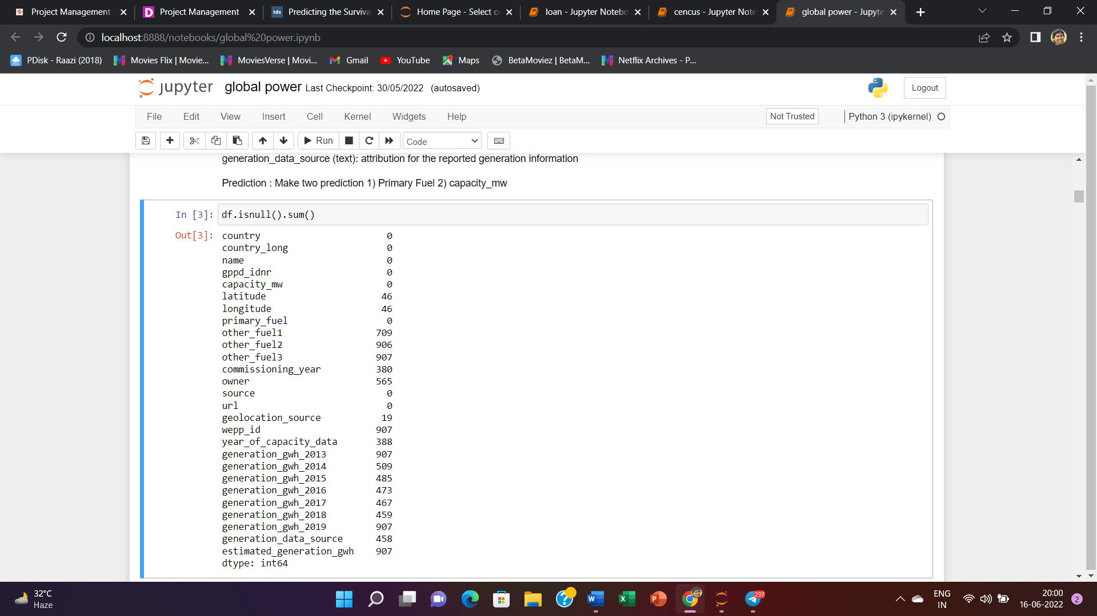

A lot of missing values are there in the data set . In the next step we have to remove some unimportant collumns and missing values.

"estimated_generation_gwh","owner","year_of_capacity_data","commissioning_year","generation_data_source","generation_gwh_2019", "wepp_id" ,"generation_gwh_2013" ,"other_fuel2" ,"other_fuel3" and "other_fuel1" are some unimportant features that we have removed from the data set.

we have to take care all the missing values , so that there will be no missing values in the dataset .

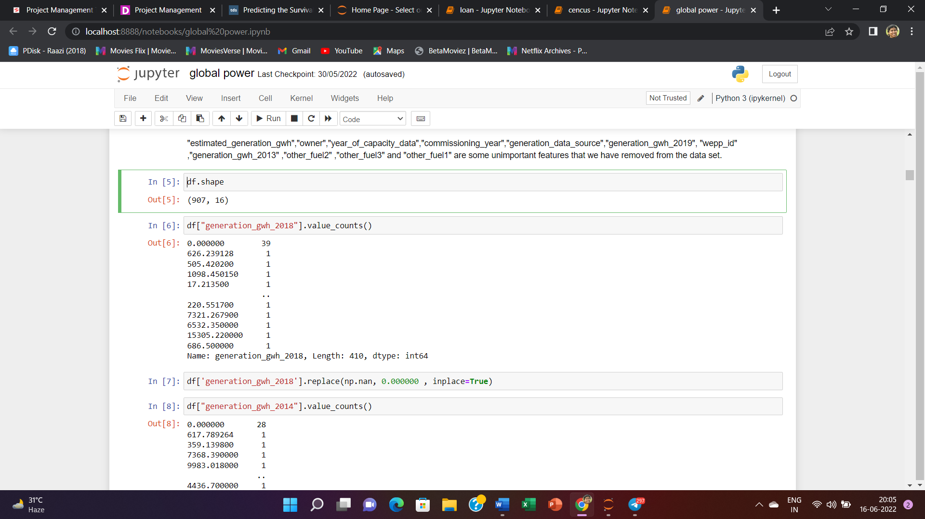

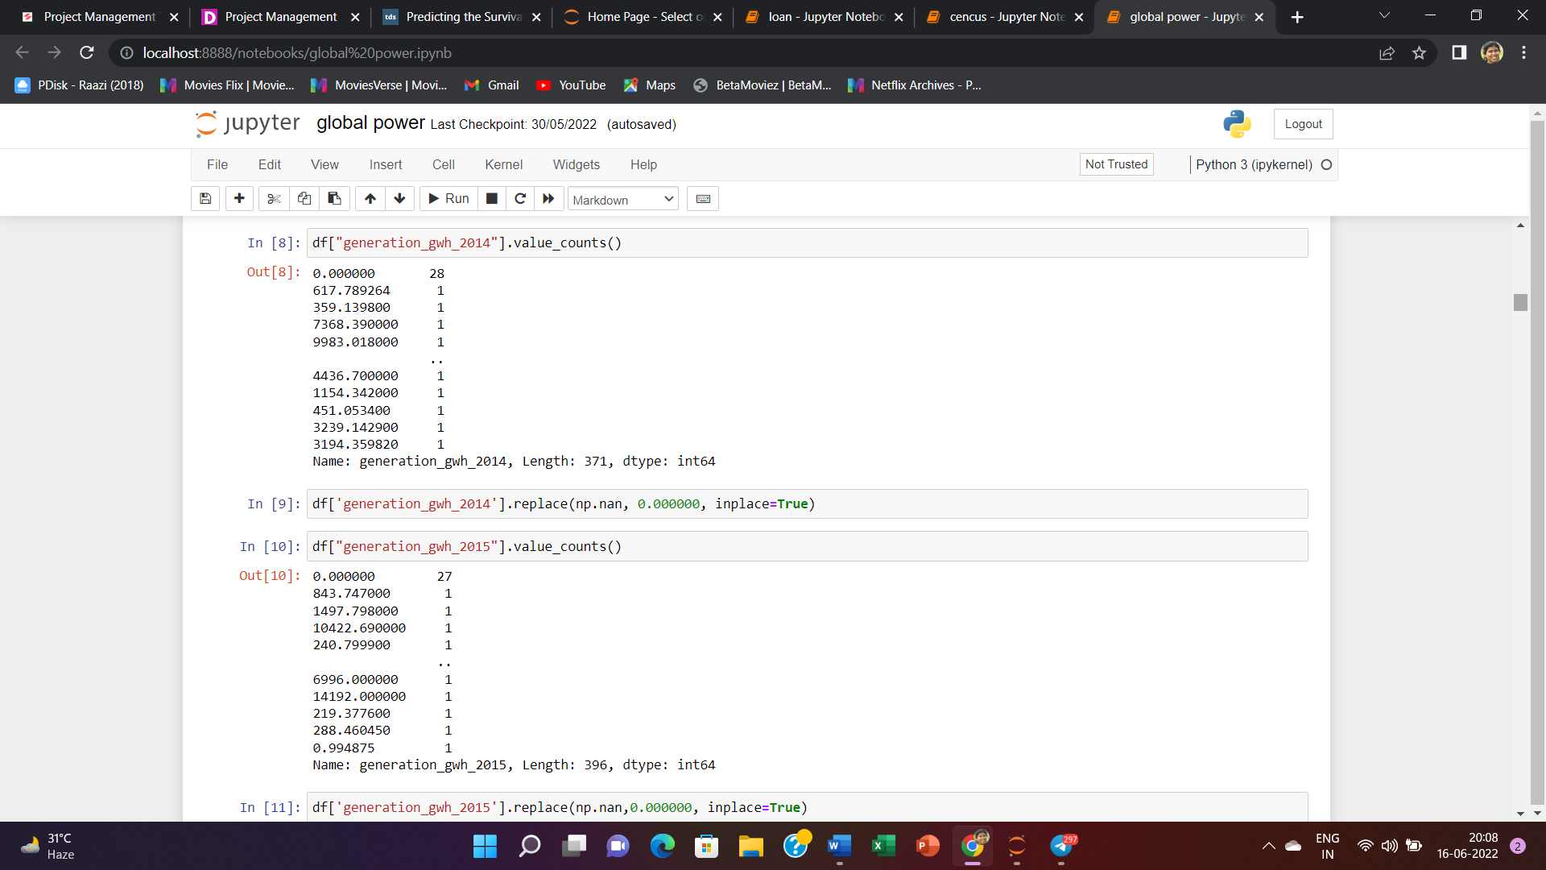

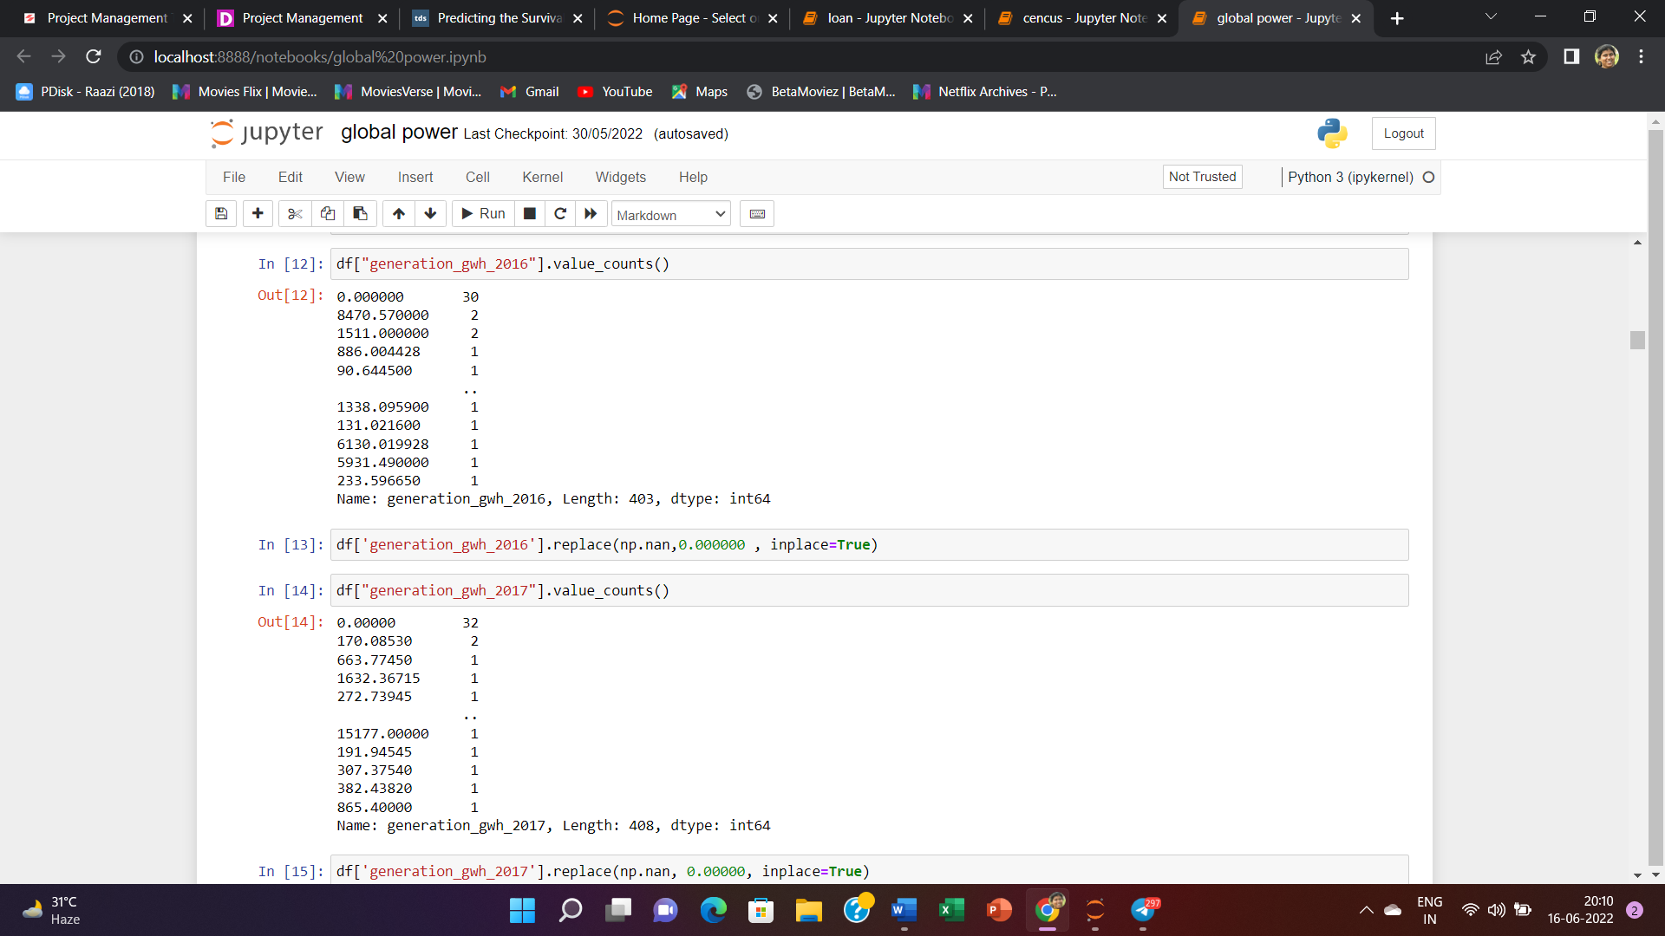

In most of features we have replaed the nan values with most frequent values of those features.

Now we have to handle the missing values of Latitude and Longitude features .Here also we have replaced the missing values with most frequent values.

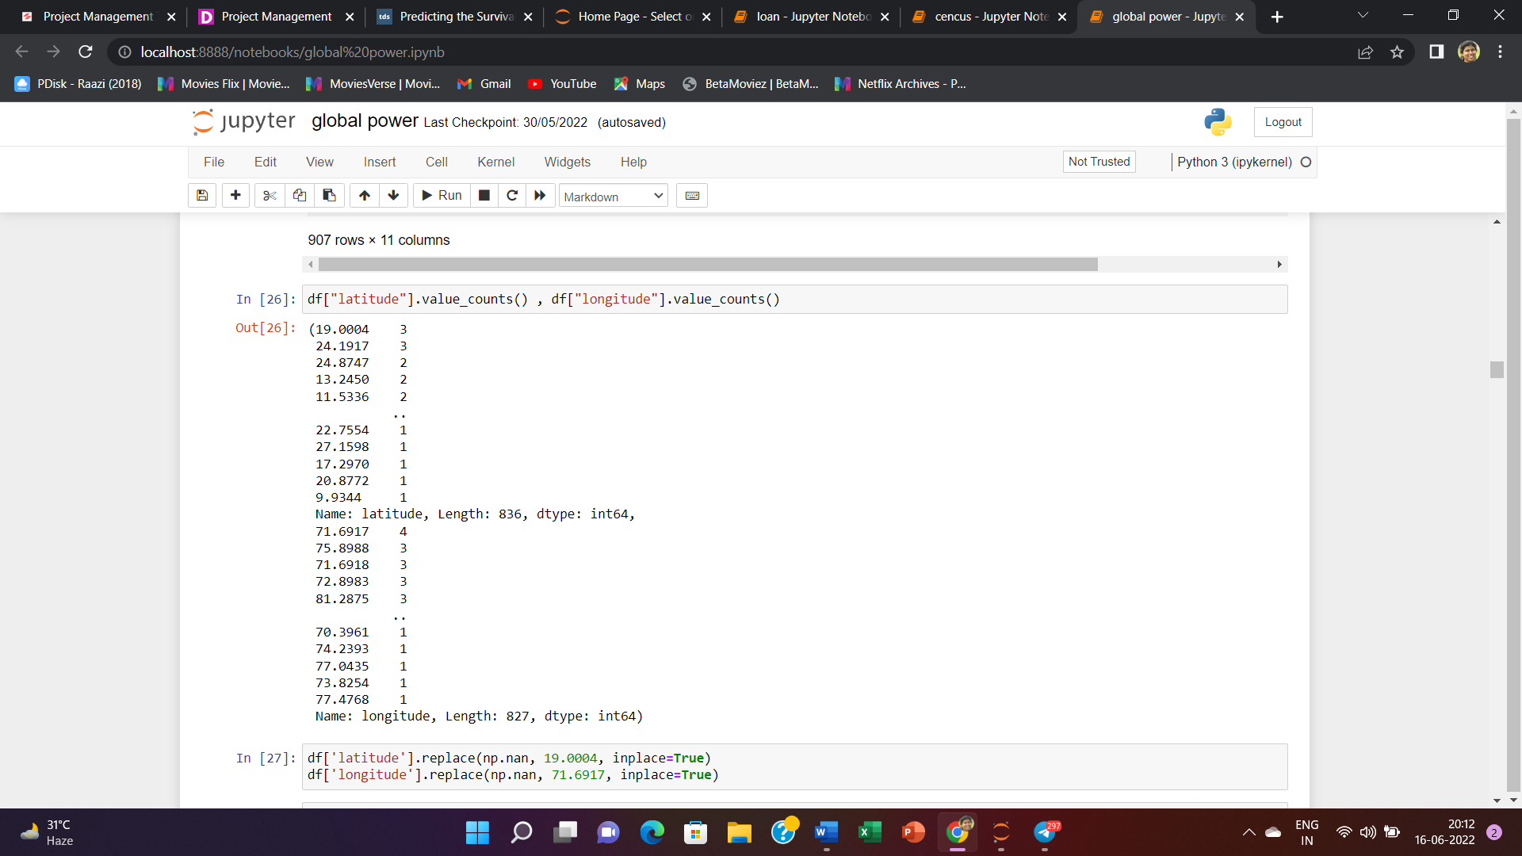

Now there is no missing values in the dataset .

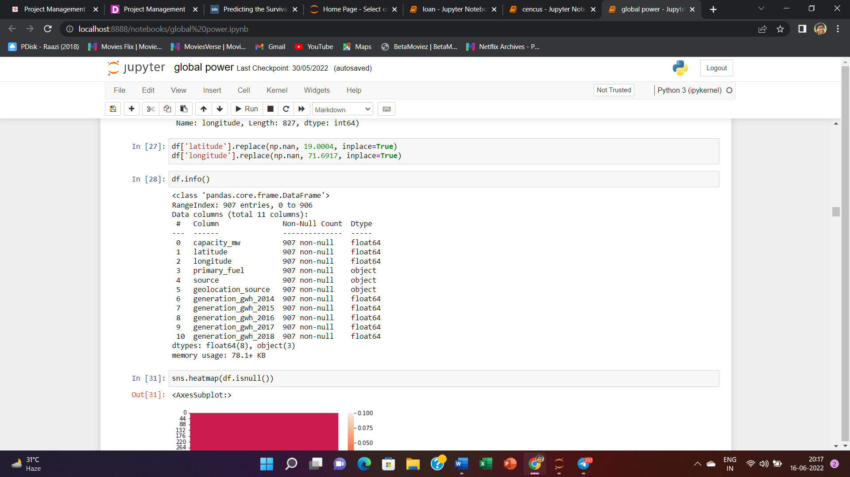

From above information we can see that after removing all unimportant features , missing values now there are 11 features in the dataset . Among them three features are object features . Now we will encode this object Features .

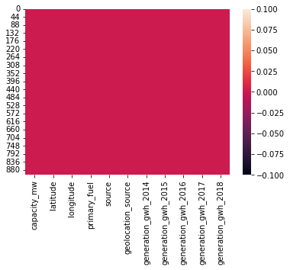

From this above heatmap we can visualise that there is no missing values in the dataset.

now we will be doing some univariate and multivariate analysis and will visualise the same through

graphs.

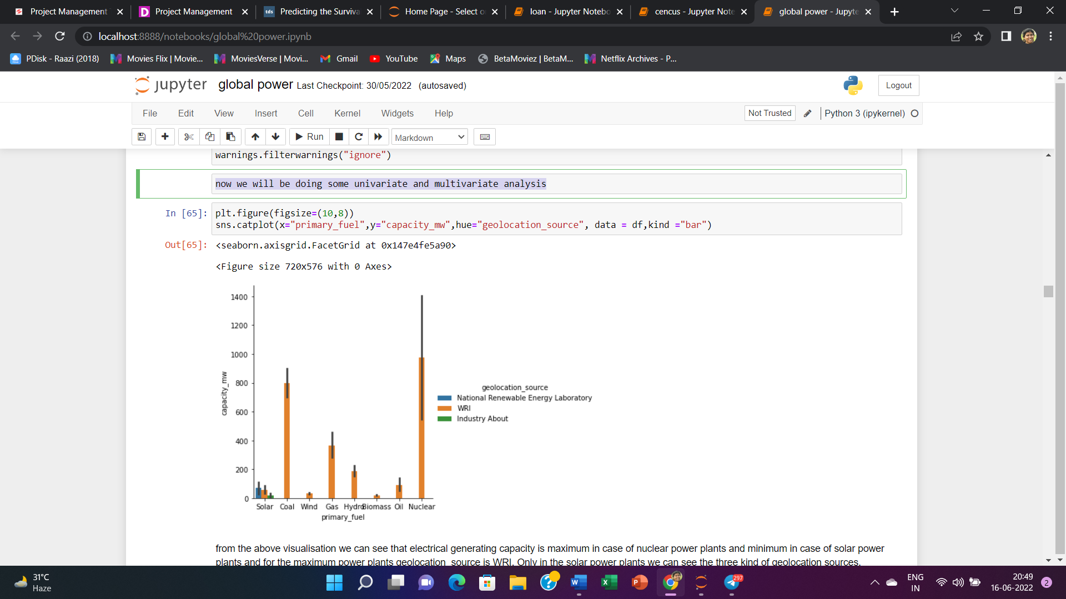

from the above visualisation we can see that electrical generating capacity is maximum in case of nuclear power plants and minimum in case of solar power plants and for the maximum power plants geolocation_source is WRI. Only in the solar power plants we can see the three kind of geolocation sources.

it is clearly shown that neauclear power plant is the first and then coal power plant comes in the second position in generating electrical generating capacity from 2014 to 2018.

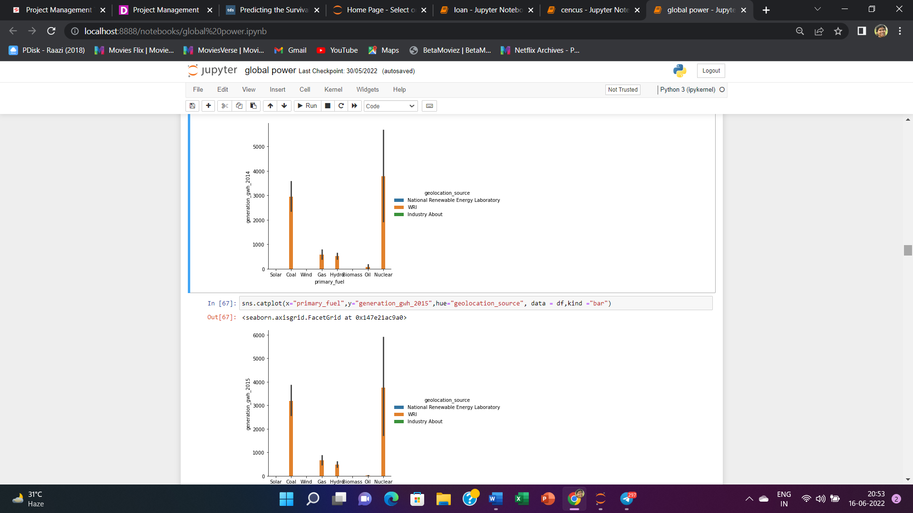

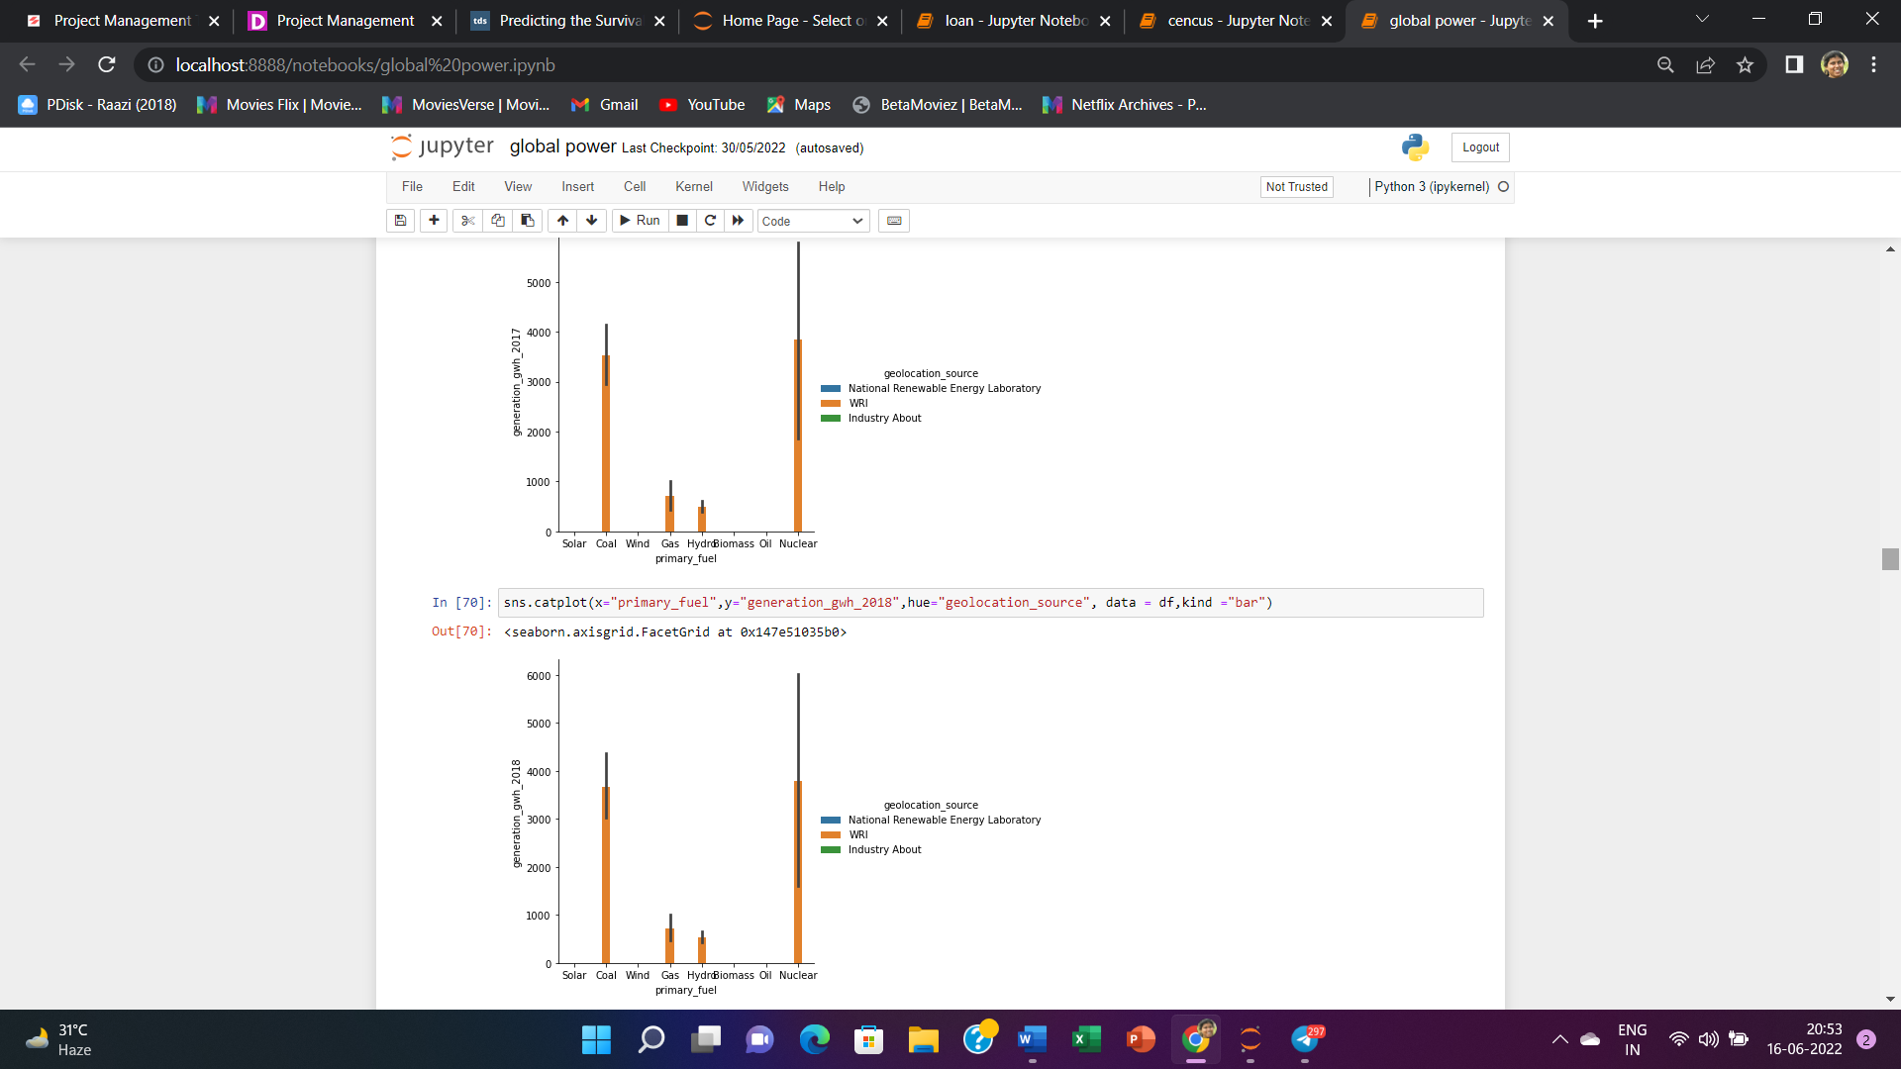

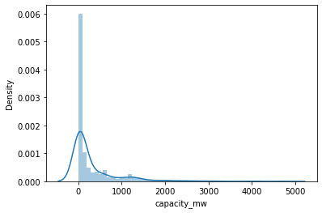

We can see the dist plot of capacity mw , it is clearly shown that the dataset is skewed.

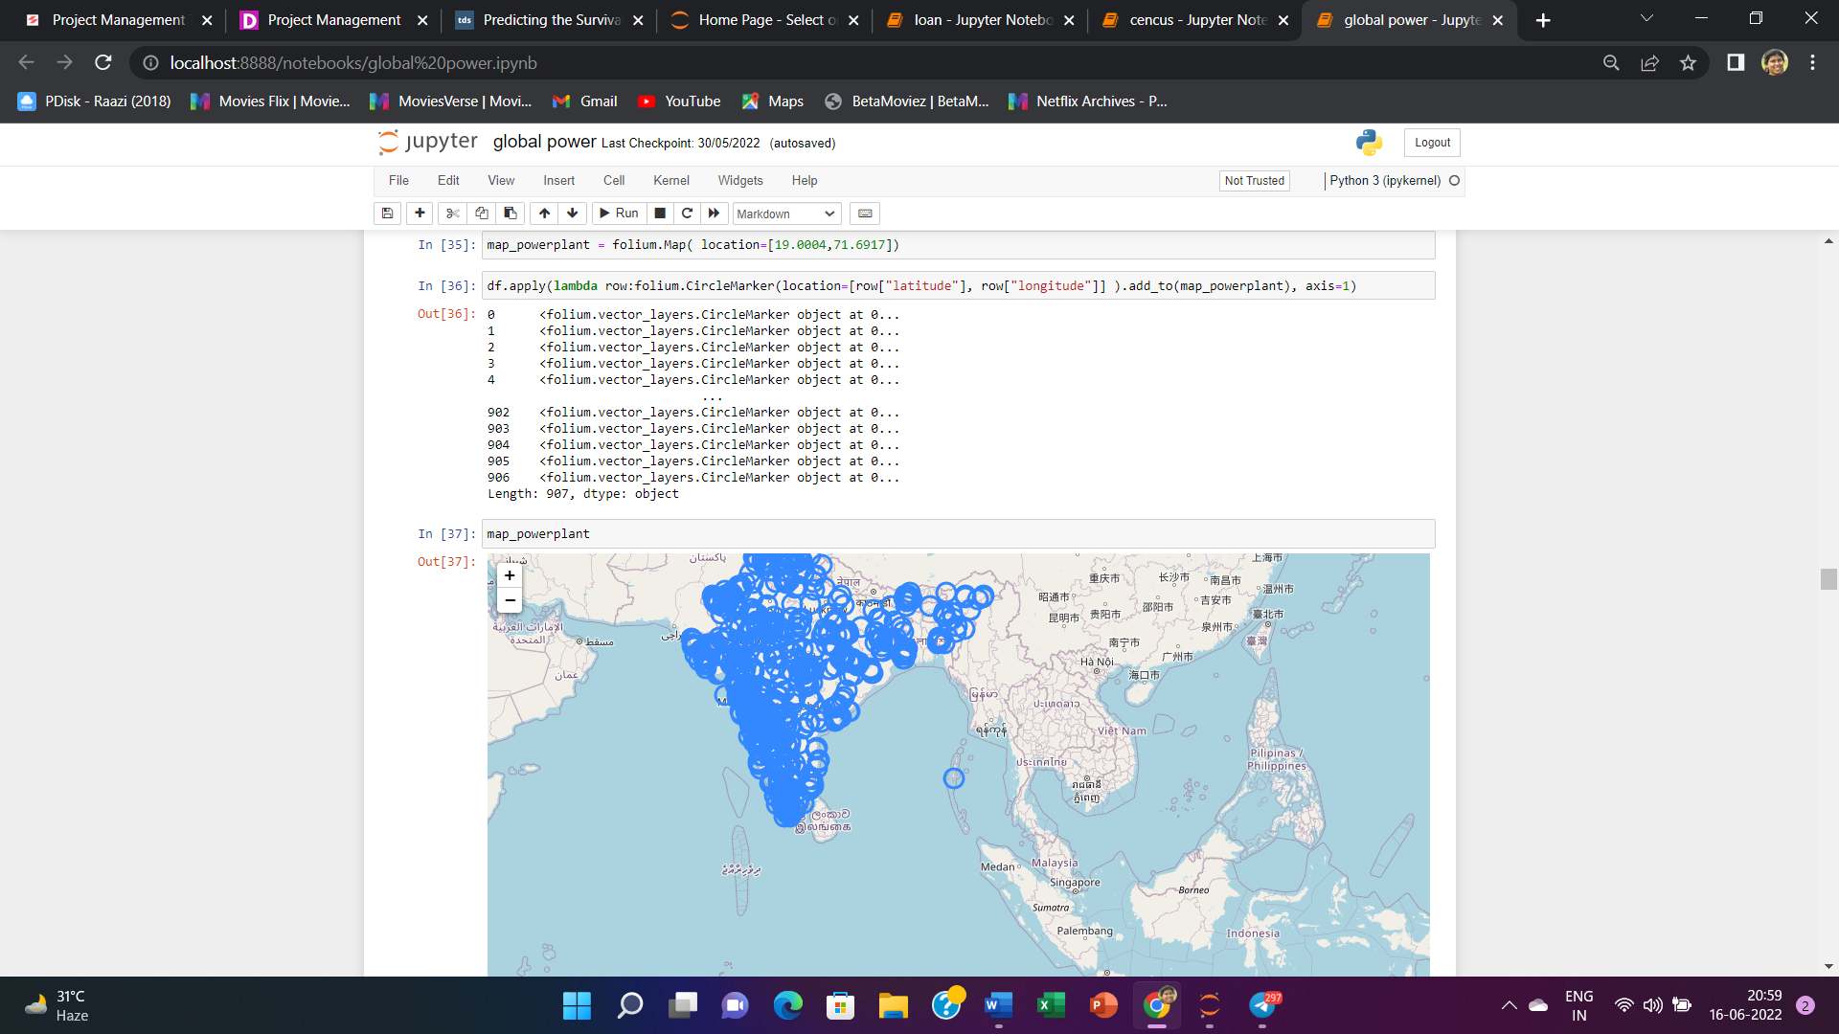

Here we have installed folium and geopy to visualise the map and the location of the power plants using latitude and longitude values.

Now we will use ordinal encoder to encode the categorical columns .

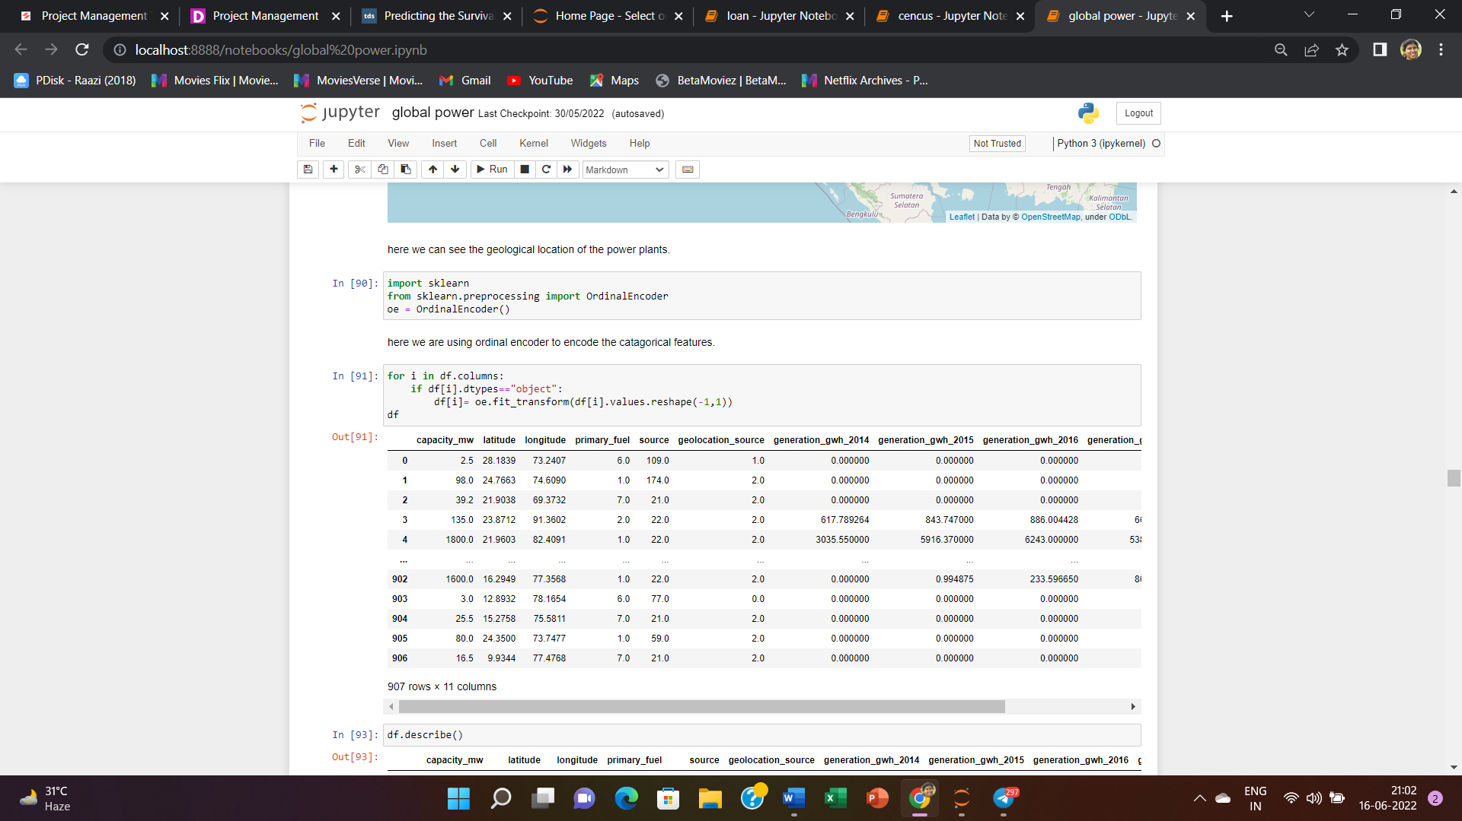

Now we will see the statistical description and the heatmap of correlation between various features of the dataset.

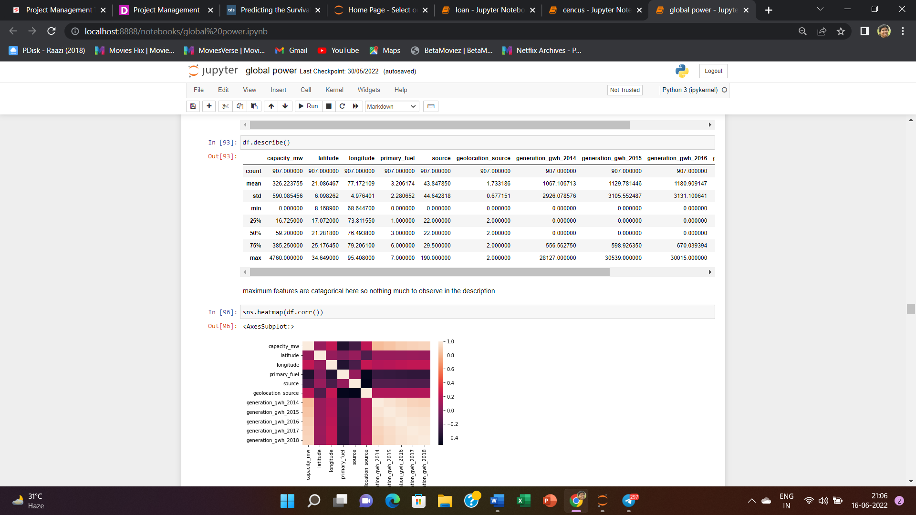

maximum features are catagorical here so nothing much to observe in the description

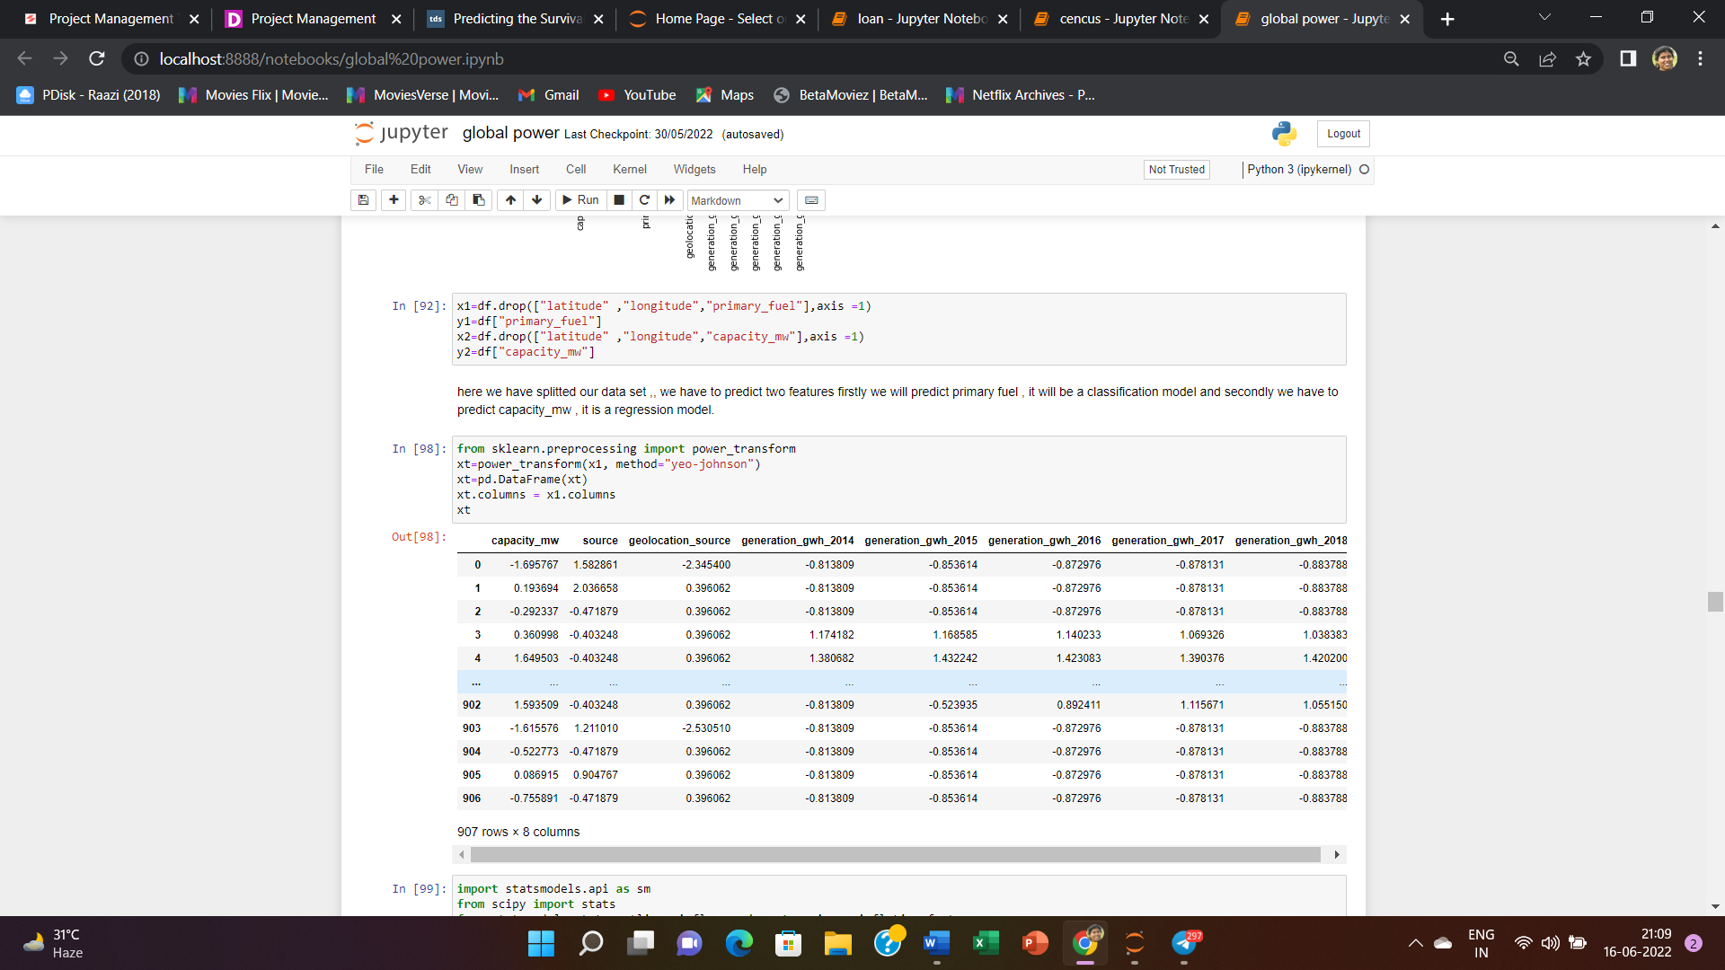

Here we have used power transform Yeo_johnson method to transform the dataset and remove skewness.

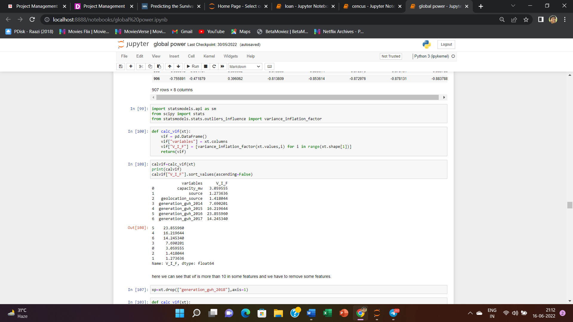

Here we have imported statsmodel , scipy library and varience _ inflation_factor to check if there is any multicollinearity present in the dataset and we can see that VIF is more than 10 in generation growth of various years lie 2015, 2016 , 2017 ,, so we have to remove some features of high VIF values.

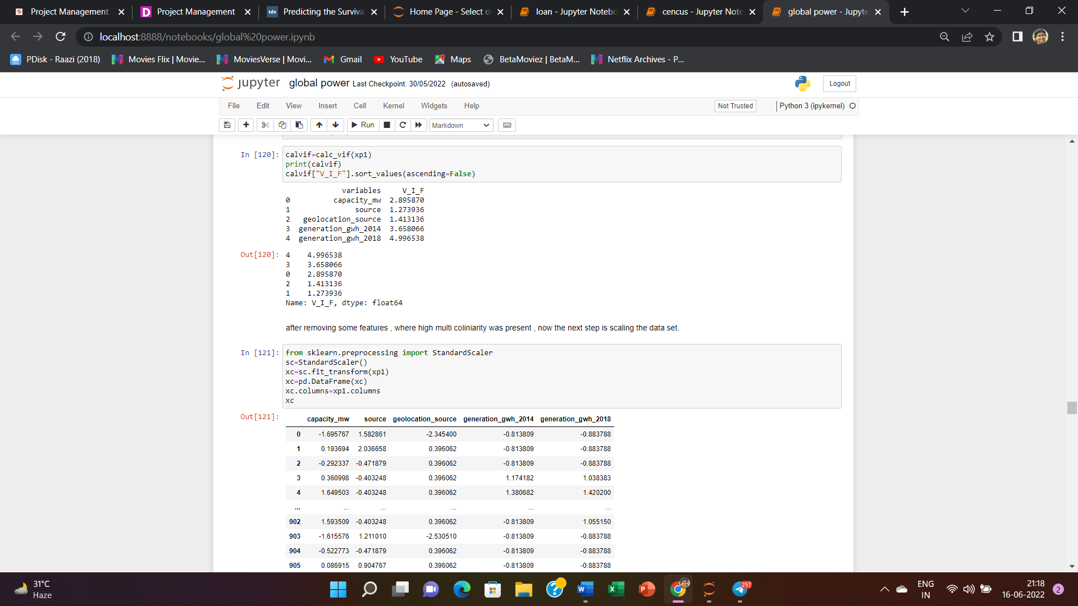

After removing the features with high VIF values now we can see that VIF values of remaining features are below 10 and then we have used standard scaler to scale the dataset .

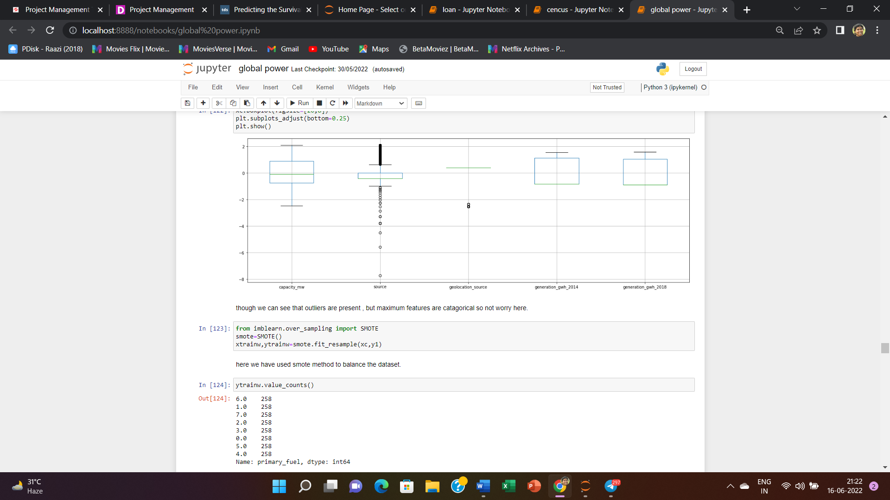

We can see in the above boxplots , that some outliers are present in the dataset , but we can ignore it because maximum features are categorical in nature.

Then we have used smote technique to balance the dataset .

Now the dataset is ready for model creation and using of different ML algorithms for making predictions .

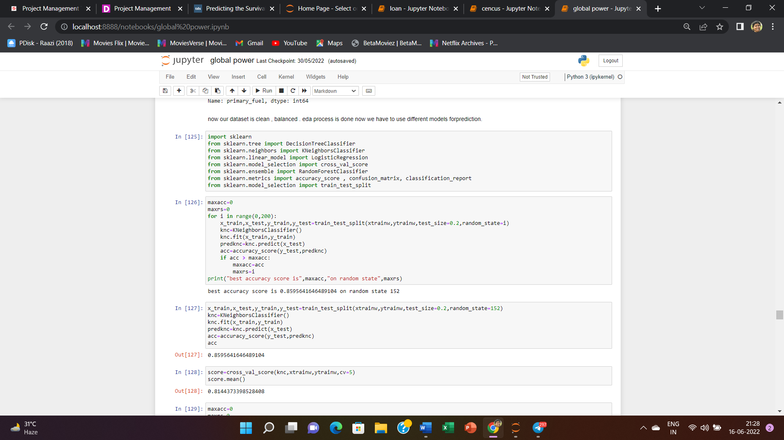

Here we have imported various classification models as our first prediction model is primary fuel and it is a classification model .



At first we have used k_neighbours classifier and at random state 152 it has given the best score that is around 86% where the cross validation score for this model is 82 % , that is also very near to the model score .

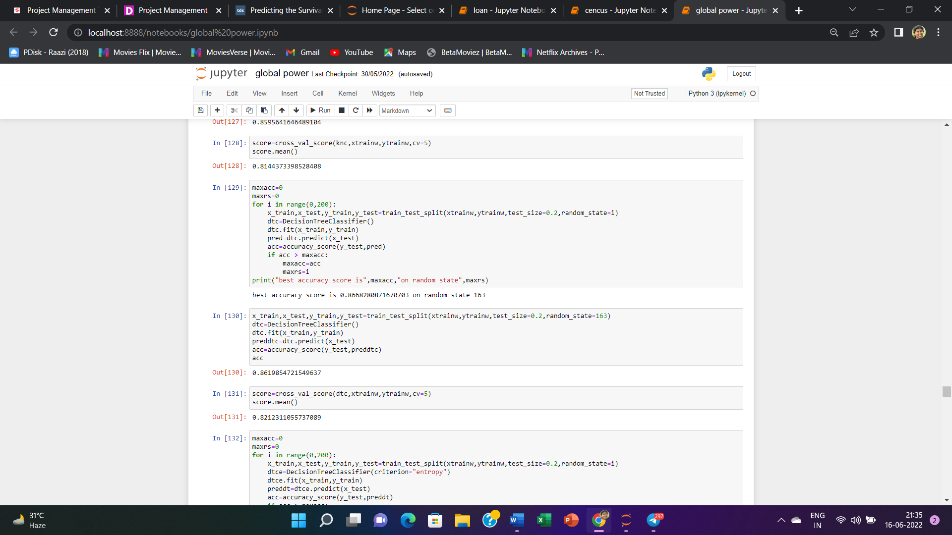

Now we have used decision tree classifier and at random state 163 it has given the best score that is around 86% where the cross validation score for this model is 82 % , that is also very near to the model score . here wehave not mentioned the criterion , so by default the criterion is genny .

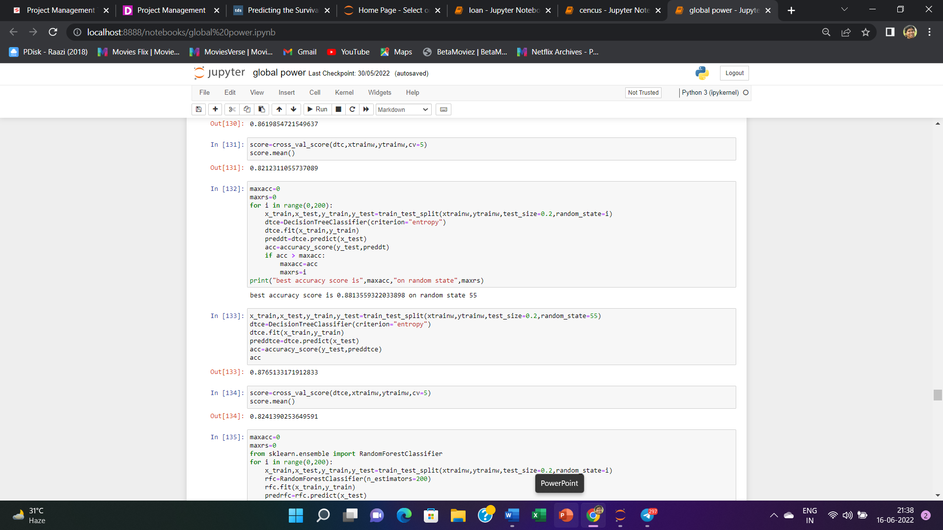

Now we have used decision tree classifier where the criterion is entropy and at random state 55 it has given the best score that is around 88% where the cross validation score for this model is around 88 % , that is also very near to the model score .

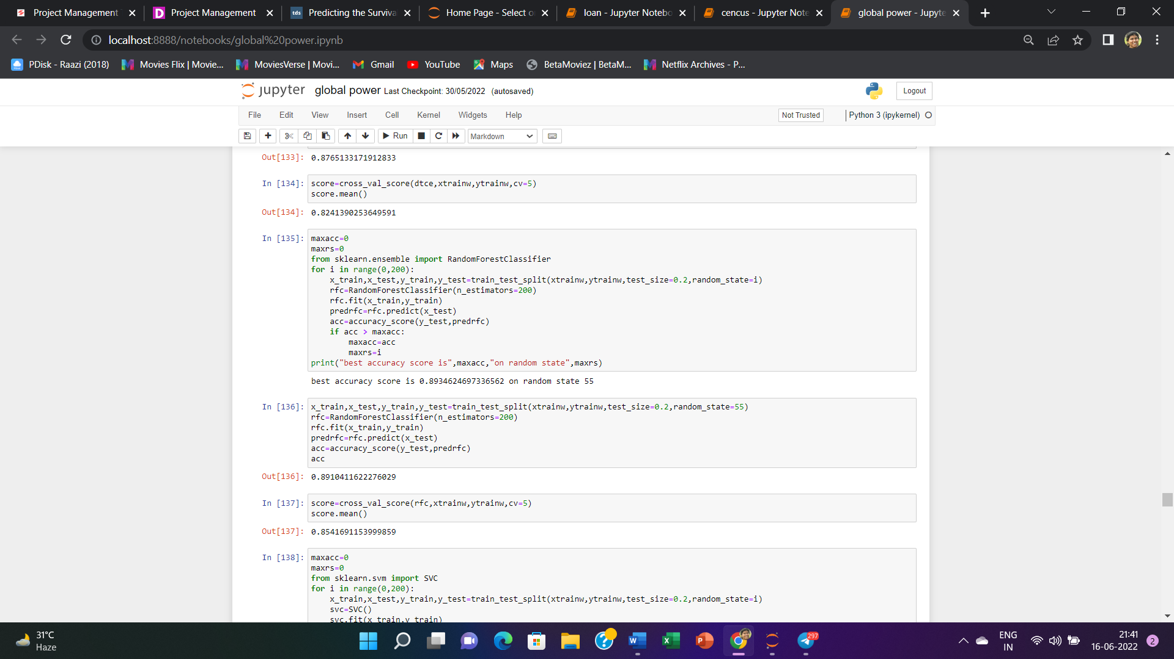

Now we have used Random Forest classifier where the criterion is entropy and at random state 55 it has given the best score that is around 89% where the cross validation score for this model is around 85 % , that is also very near to the model score .

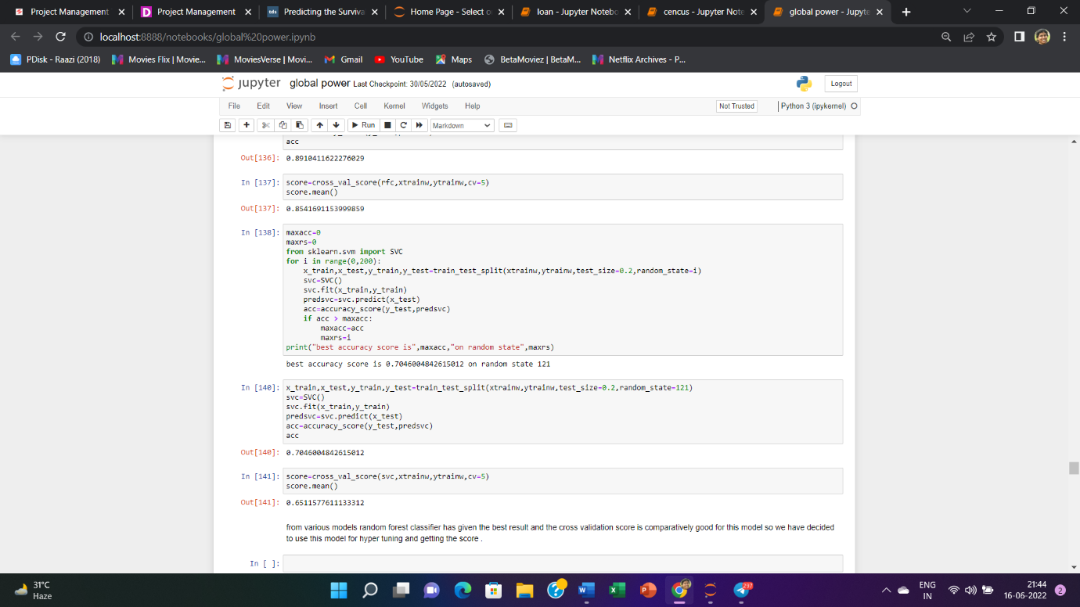

Now we have used SupportVector classifier where the criterion is entropy and at random state 121 it has given the best score that is around 70% where the cross validation score for this model is around 65 % , that is also very near to the model score . SVC has given verry poor results in comparison to other models.

from various models random forest classifier has given the best result and the cross validation score is comparatively good for this model so we have decided to use this model for hyper tuning and getting the score

now we will do hyper tunning for random forest classifier model and for that we will import gridsearch cv then we will check the best parametes and best estimators for the same.

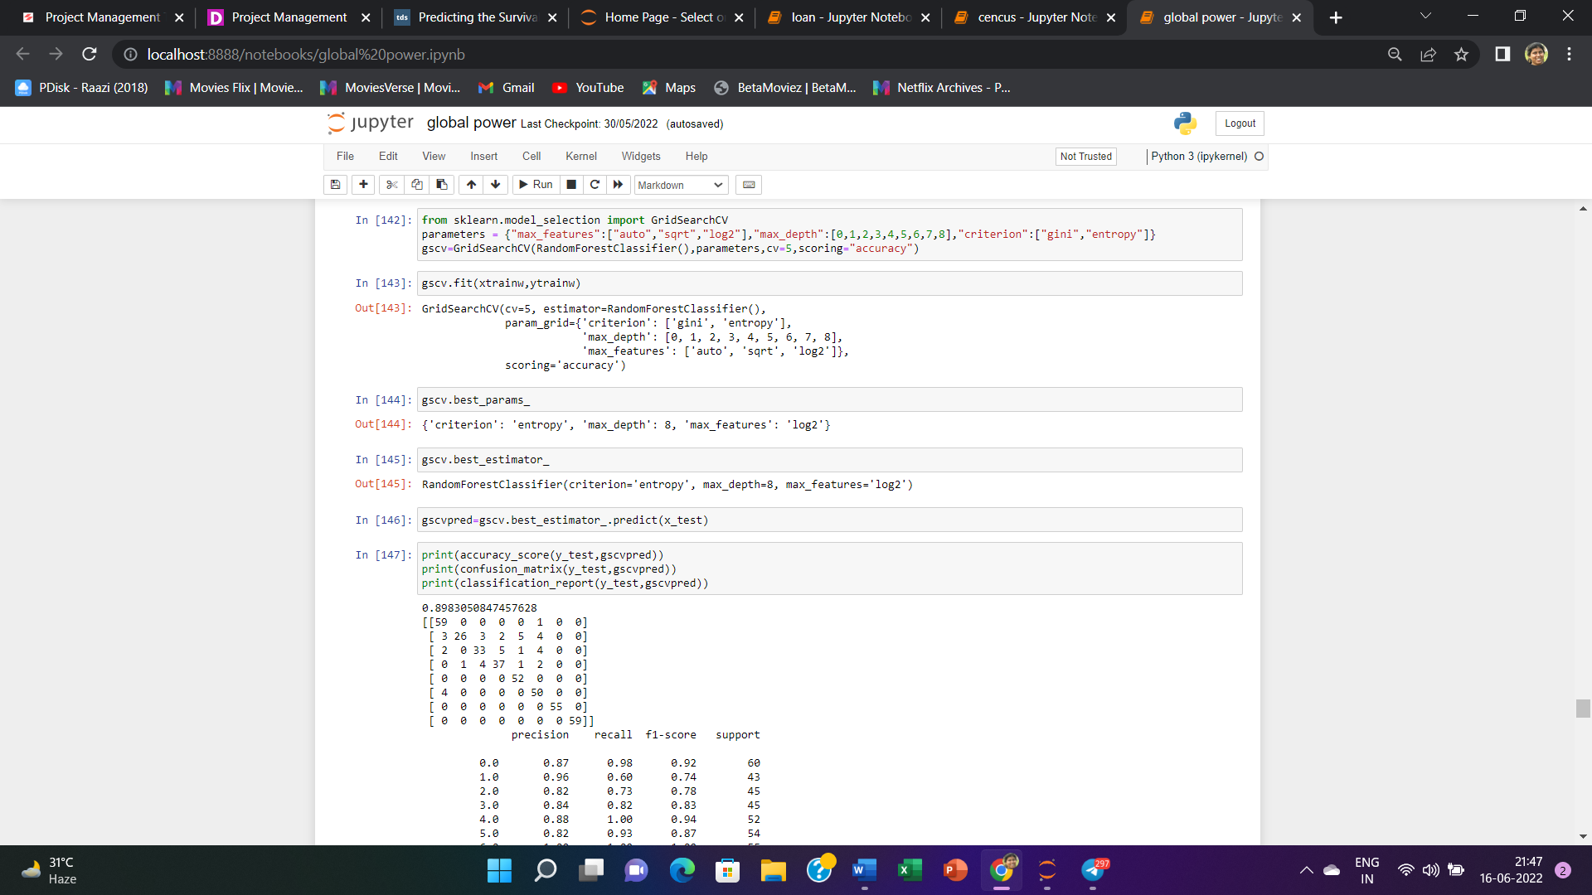

in the first model the accuracy score is around 90 % and cross validation score is around 82% .

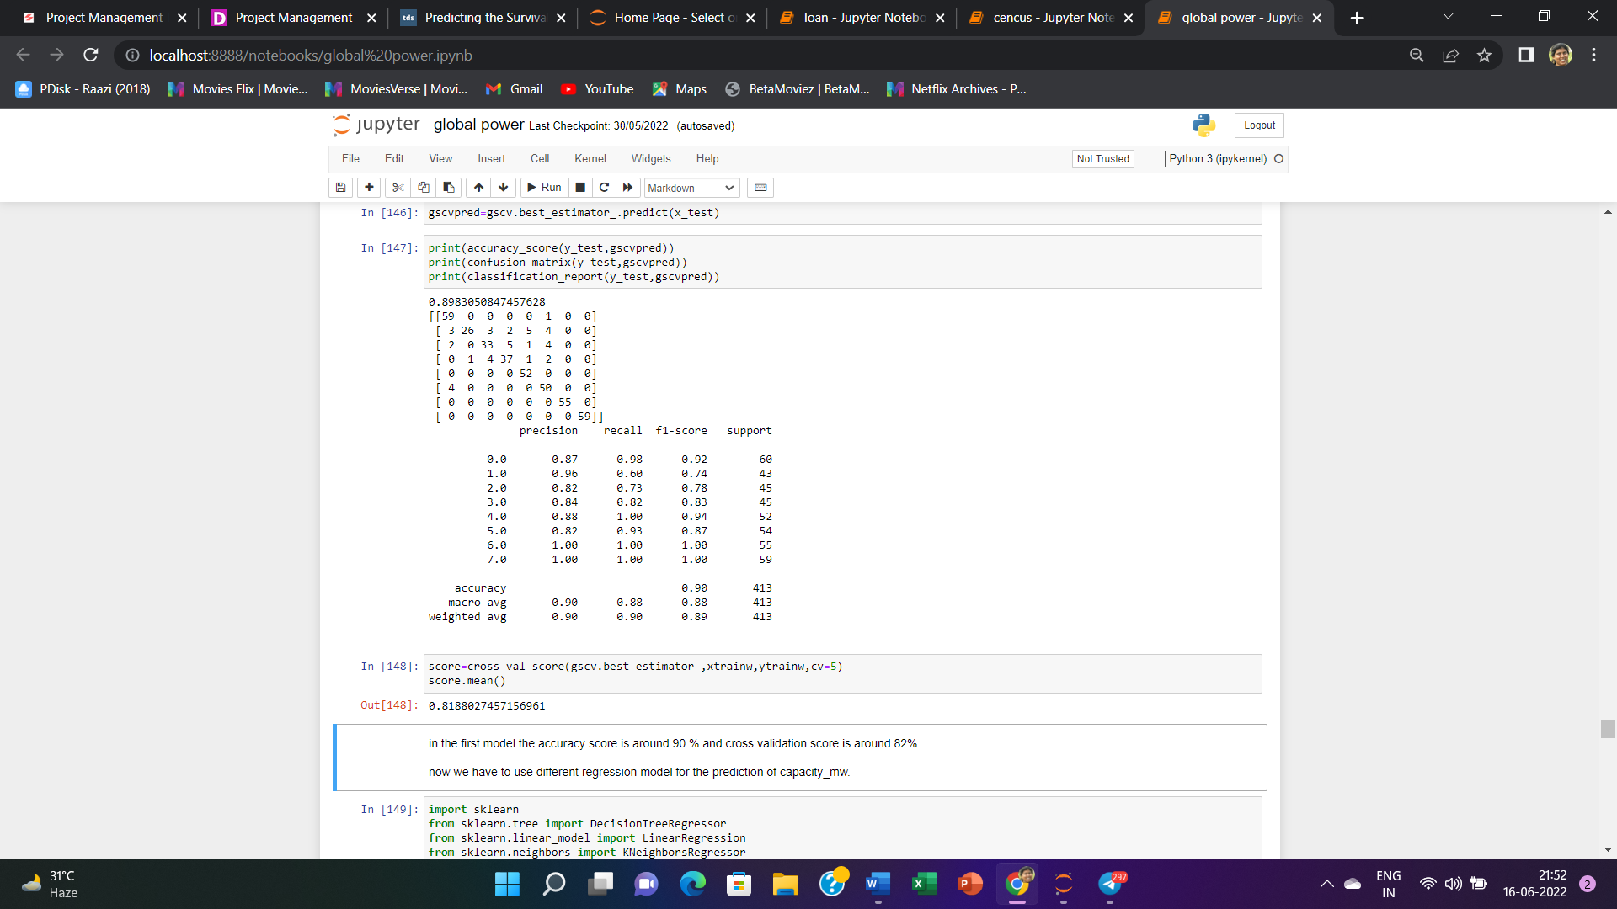

Here we can also check the confusion matrix , precision value , recall value and f1 scoreas well.

Now we have to use different regression model for the prediction of capacity_mw.

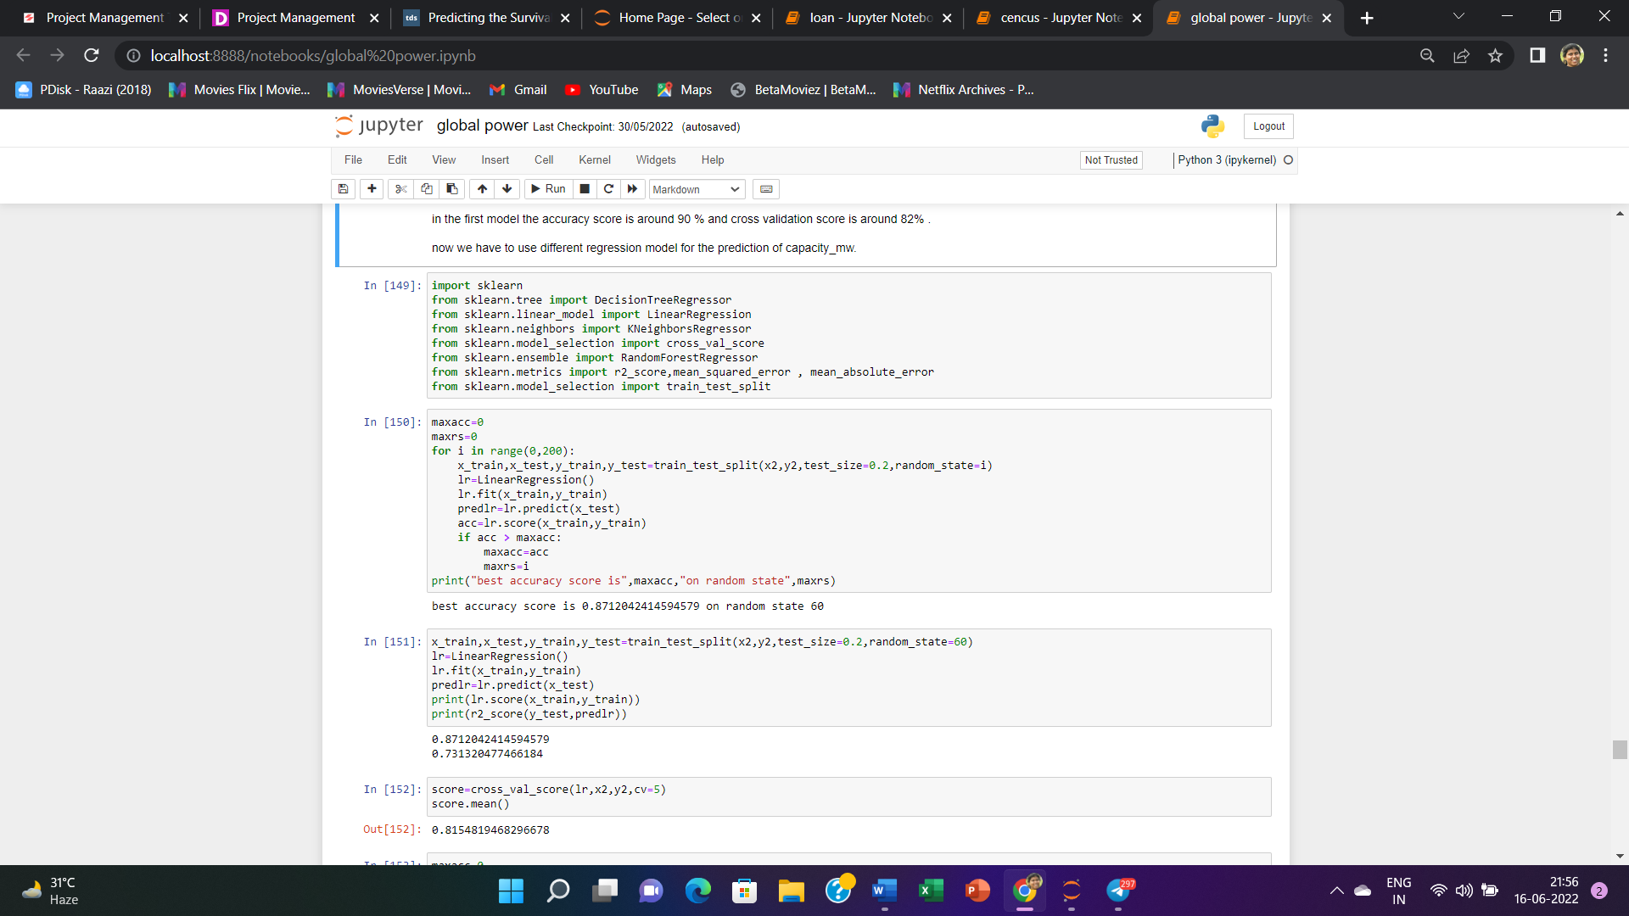

Here we have imported different regression models .

First we have used Linear Regression model and at random state 60 it has given the best score that is around 87% where the cross validation score for this model is around 82 % , that is also very near to the model score

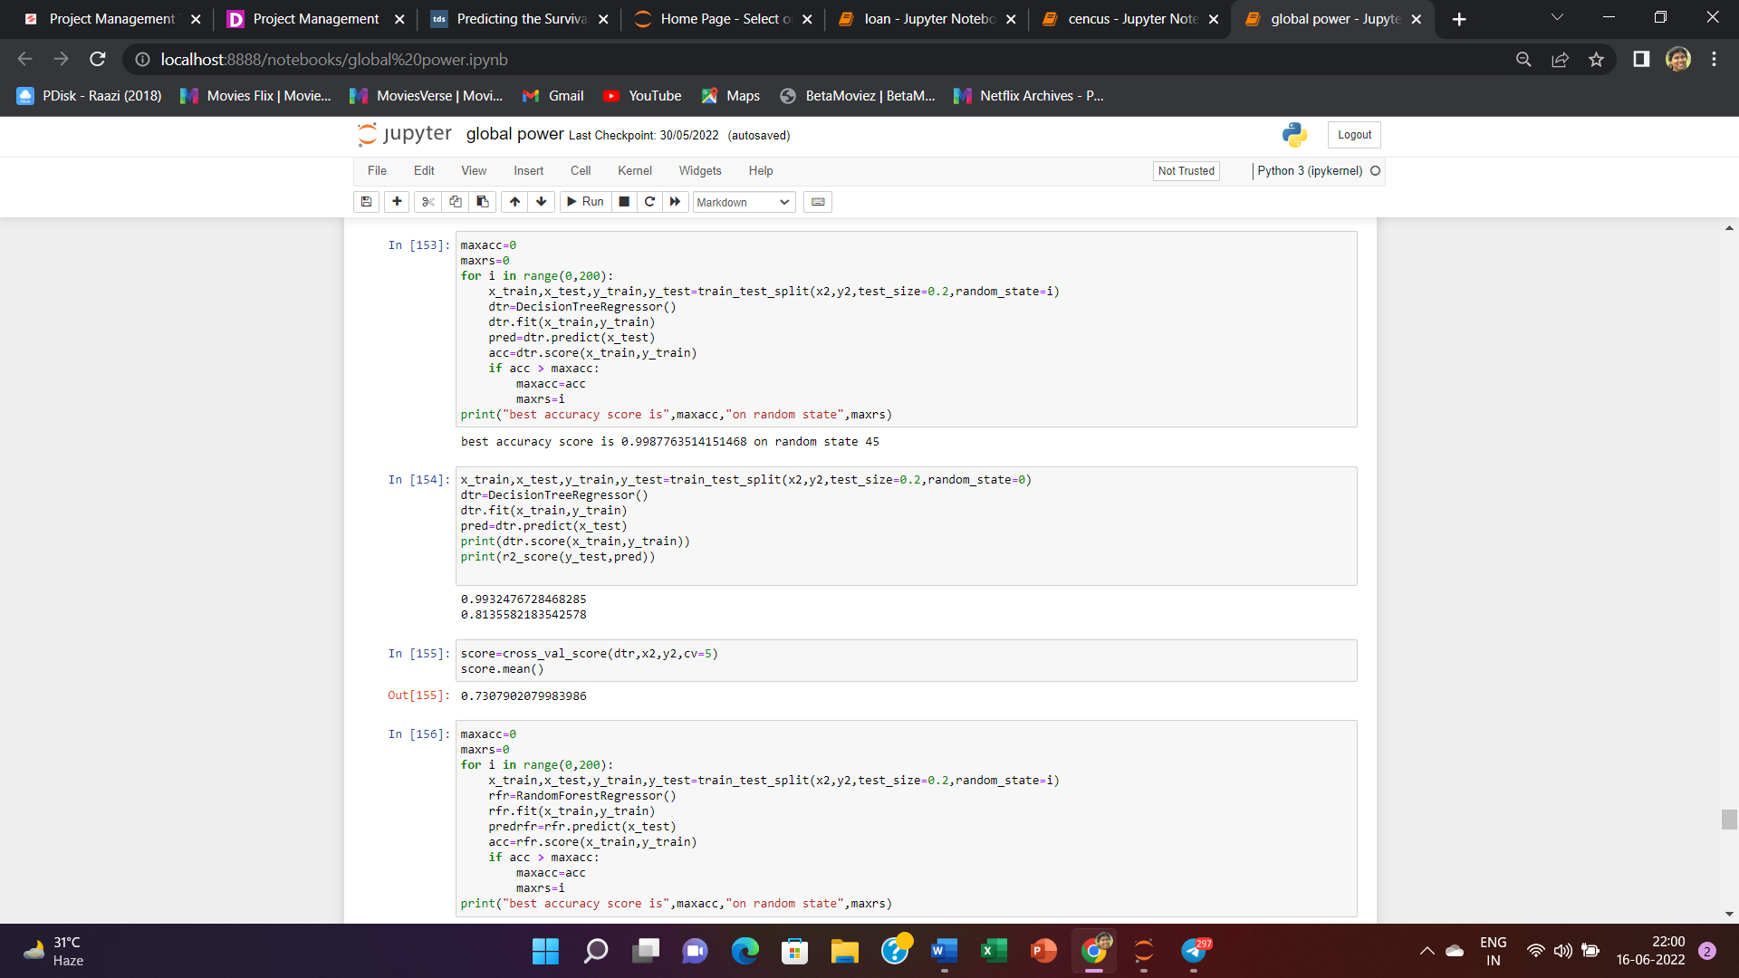

Now we have used Decision tree Regression model and at random state 0 it has given the best score that is around 99% where the cross validation score for this model is around 73 % .

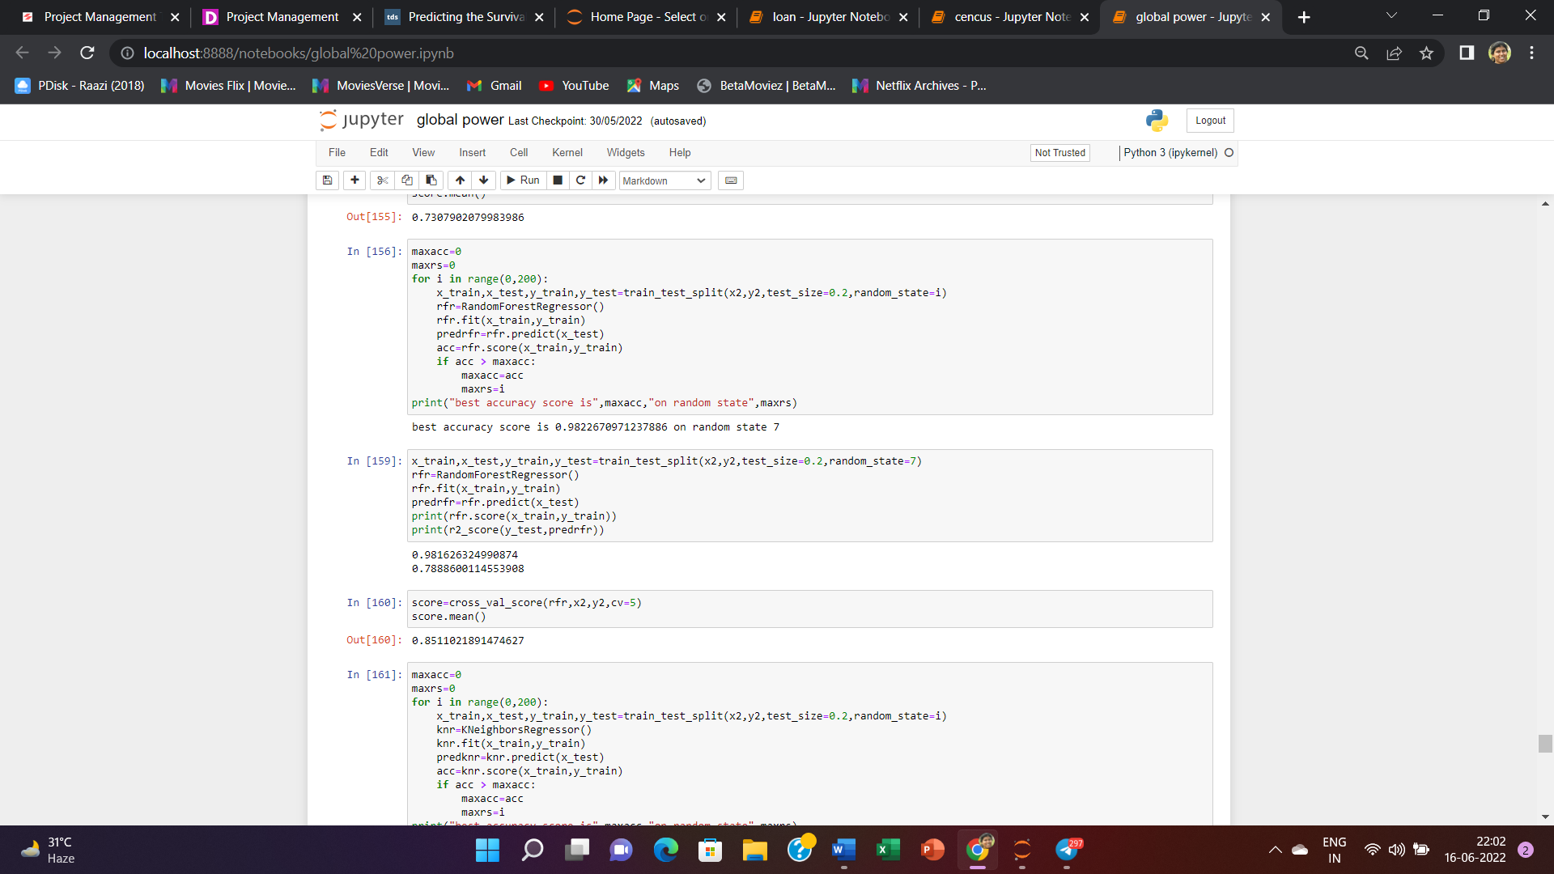

Now we have used Random Forest Regression model and at random state 7 it has given the best score that is around 98% where the cross validation score for this model is around 85 % , that is also very near to the model score .

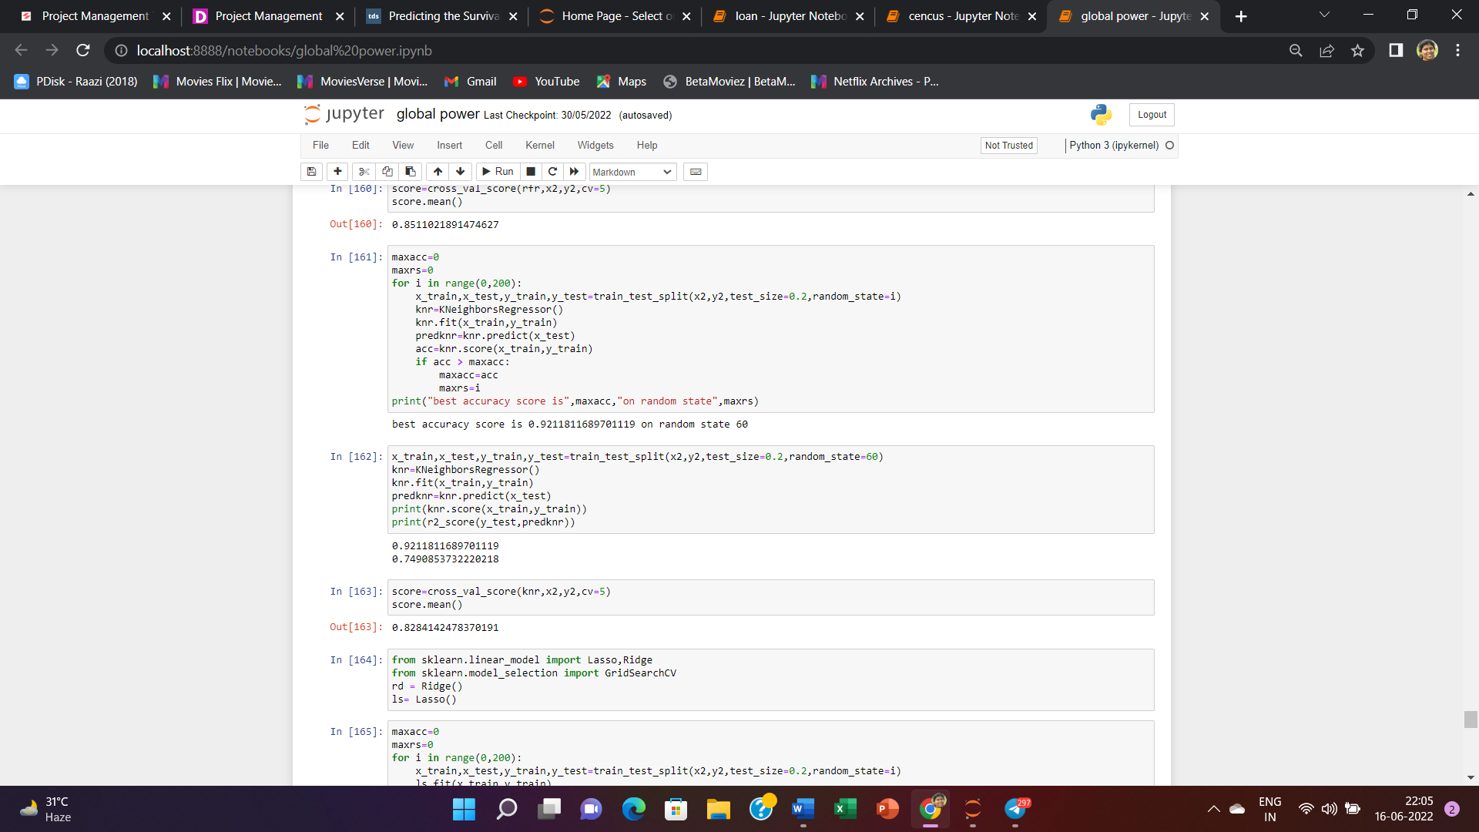

Now we have used KNeighbous Regression model and at random state 60 it has given the best score that is around 92% where the cross validation score for this model is around 82 % , that is also very near to the model score , but r2 score is poor ,75% .

Now we will import Lasso and Ridge regression to check whether the the model is over fitted or underfitted it will give the better scores.

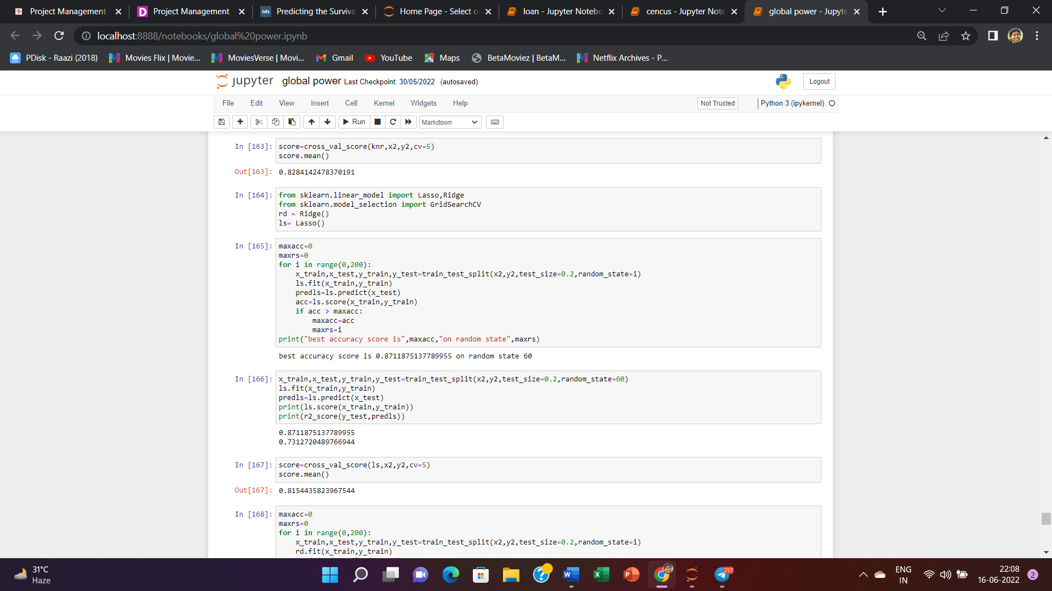



At random state 60 Lasso Regression has given the best score that is around 87% where the cross validation score for this model is around 82 % , that is also very near to the model score , but r2 score is poor ,73% .

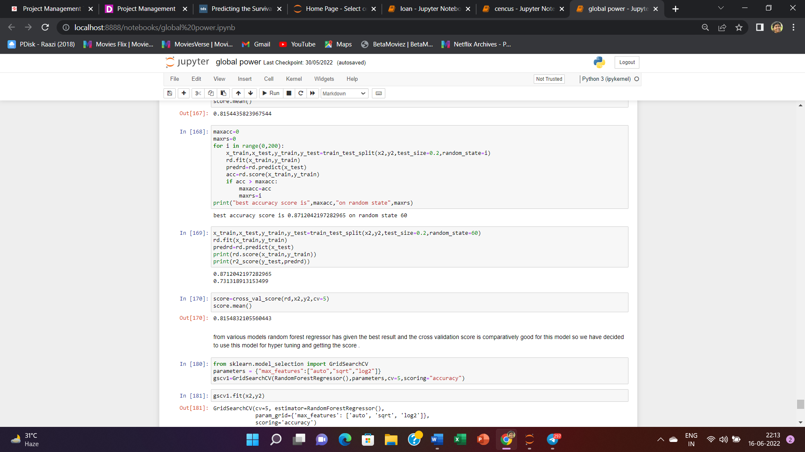

At random state 60 Ridge Regression has given the best score that is around 87% where the cross validation score for this model is around 82 % , that is also very near to the model score , but r2 score is poor ,73% .

Random Forest

What is Random Forest ?

Random Forest is a supervised learning algorithm. Like you can already see from it’s name, it creates a forest and makes it somehow random. The „forest“ it builds, is an ensemble of Decision Trees, most of the time trained with the “bagging” method. The general idea of the bagging method is that a combination of learning models increases the overall result.

To say it in simple words: Random forest builds multiple decision trees and merges them together to get a more accurate and stable prediction.

One big advantage of random forest is, that it can be used for both classification and regression problems, which form the majority of current machine learning systems. With a few exceptions a random-forest classifier has all the hyperparameters of a decision-tree classifier and also all the hyperparameters of a bagging classifier, to control the ensemble itself.

The random-forest algorithm brings extra randomness into the model, when it is growing the trees. Instead of searching for the best feature while splitting a node, it searches for the best feature among a random subset of features. This process creates a wide diversity, which generally results in a better model. Therefore when you are growing a tree in random forest, only a random subset of the features is considered for splitting a node. You can even make trees more random, by using random thresholds on top of it, for each feature rather than searching for the best possible thresholds (like a normal decision tree does).

Below you can see how a random forest would look like with two trees:

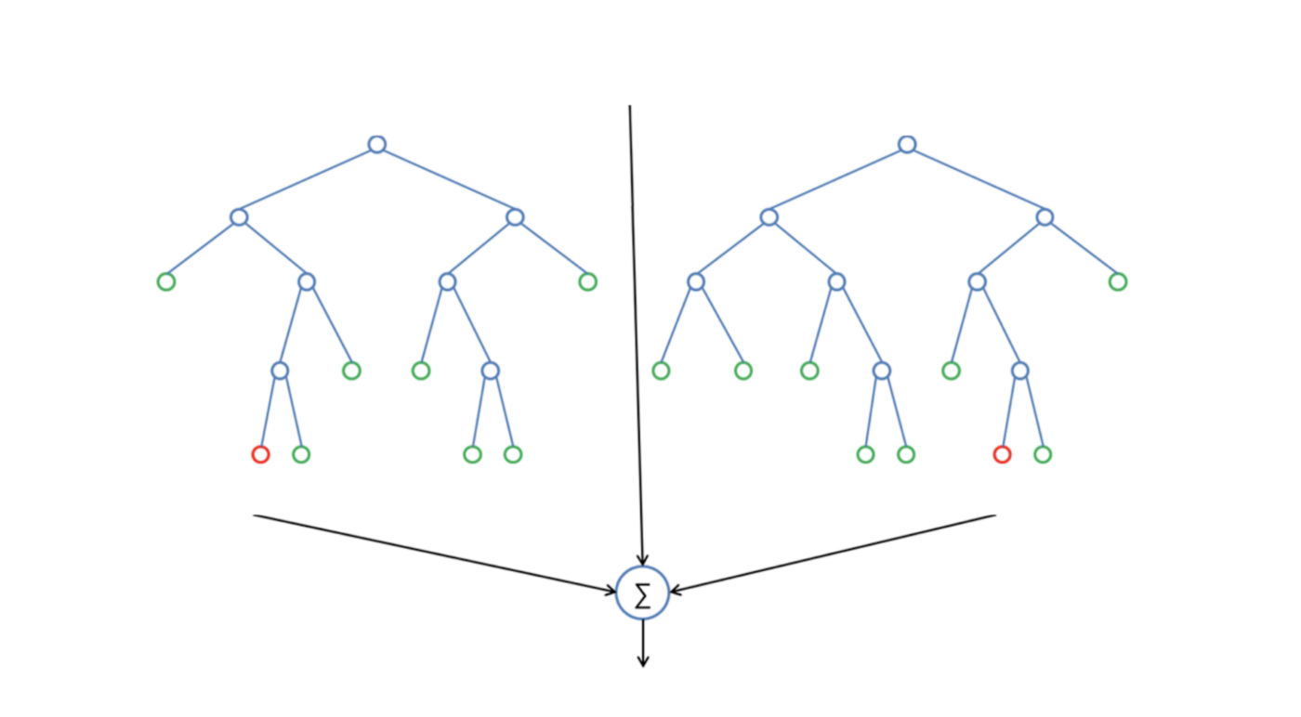

From various models random forest regressor has given the best result and the cross validation score is comparatively good for this model so we have decided to use this model for hyper tuning and getting the score .

For that we will import gridsearch cv then we will check the best parametes and best estimators for the same.

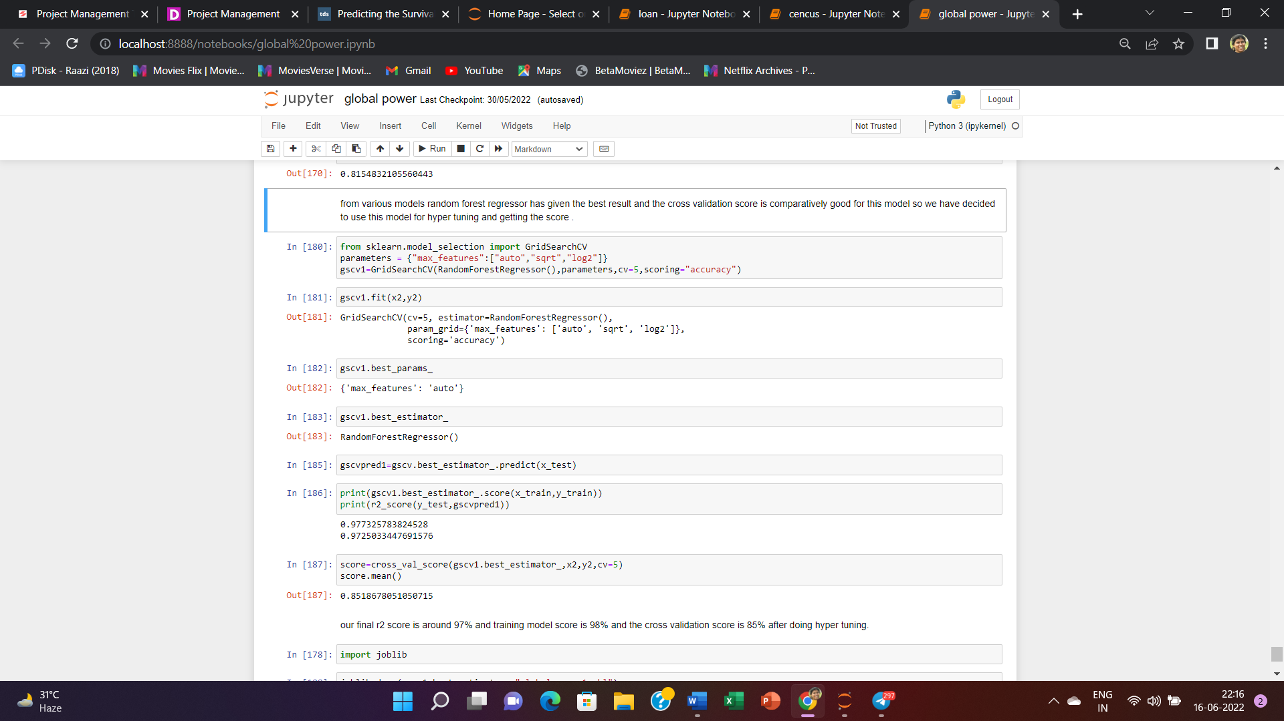

Here we can see that our model score is around 98% , r2 score is 97 % and te cross validation score is 85%.

Now we will import joblib for deploying our models.

